The Development of a Microwave Engine for Spacecraft Propulsion

Roger Shawyer

SPR Ltd
www.emdrive.com

Background

A major cost driver in the satellite communications industry is the cost of launch, particularly where geostationary orbit (GEO) is required. Transfer from low Earth orbit (LEO) to GEO using electric propulsion has been proposed to cut costs, but is currently still not used. What is clearly needed is a new electric propulsion technology offering a significant improvement in performance.

In 2001 a small UK company, Satellite Propulsion Research Ltd (SPR), was set up to carry out an R&D programme into a revolutionary electrical propulsion concept. The proposed technology would provide direct conversion from electrical energy to thrust, without the need to expel any form of propellant. The system performance offered would halve the cost of launch to GEO and extend the operational lifetime of the satellite.

Significant preparatory work had already been carried out, and resulted in the award of a feasibility study under the DTI SMART programme. This study completed the theoretical work and enabled an experimental programme to be carried out. The resulting test data confirmed the theoretical thrust predictions. The study results were independently reviewed and further support was then given by the DTI in the form of a Research and Development grant. This has enabled work to be started on the design, manufacture and test of a complete Demonstration Engine. The £250,000 programme is presently on target to provide a convincing demonstration of the technology.

Principle of Operation

At first sight the idea of propulsion without propellant seems impossible. However the technology is firmly anchored in the basic laws of physics and following an extensive review process, no transgressions of these laws have been identified.

The principle of operation is based on the well-known phenomenon of radiation pressure. This relies on Newton’s Second Law where force is defined as the rate of change of momentum. Thus an electromagnetic (EM) wave, travelling at the speed of light has a certain momentum which it will transfer to a reflector, resulting in a tiny force.

If the same EM wave is travelling at a fraction of the speed of light, the rate of change of momentum, and hence force, is reduced by that fraction. The propagation velocity of an EM wave, and the resulting force it exerts, can be varied depending on the geometry of a waveguide within which it travels. This was demonstrated by work carried out in the 1950’s. (Reference 1)

Thus if the EM wave travelling in a tapered waveguide is bounced between two reflectors, with a large velocity difference at the reflector surfaces, the force difference will give a resultant thrust to the waveguide linking the two reflectors. If the reflectors are separated by a multiple of half the effective wavelength of the EM wave, this thrust will be multiplied by the Q of the resulting resonant cavity, as illustrated in fig 1.

The inevitable objection raised, is that the apparently closed system produced by this arrangement cannot result in an output force, but will merely produce strain within the waveguide walls. However, this ignores Einstein’s Special Law of Relativity in which separate frames of reference have to be applied at velocities approaching the speed of light. Thus the system of EM wave and waveguide can be regarded as an open system, with the EM wave and the waveguide having separate frames of reference.

A similar approach is necessary to explain the principle of the laser gyroscope, where open system attitude information is obtained from an apparently closed system device.

Results of the Feasibility Study

The two technical objectives of the study were the derivation of a thrust equation and the verification of that equation by experiment.

The complete static thrust equation is:

$$T=\frac{2{\text{PQ}}_{u}}{c}\left(\frac{λ_{0}}{λ_{g1}}−\frac{λ_{d}}{\sqrt{e_{r}}λ_{g3}}\right){\left(1−\frac{λ_{0}λ_{d}}{\sqrt{e_{r}}λ_{g1}λ_{g3}}\right)}^{−1}$$

which can be simplified to

$T=\frac{2{\text{PQ}}_{u}D}{c}$ (1)

where T = Thrust in Newtons
P = Power in Watts
Q_{u} = Unloaded Q
D = Design Factor

A full derivation of the equation is given in reference 2.

A 160 mm diameter experimental thruster, operating at 2450 MHz was designed and built. (see fig 2) The design factor, calculated from as-built measurements of the thruster geometry was 0.497. An unloaded Q of 5,900 was measured. The maximum thrust, measured using a precision balance was 16mN for an input power of 850W, which is very close to the thrust of 16.6mN predicted from equation 1.

The thrust could be varied from zero to maximum by varying the input power, or by varying the resonant frequency of the thruster. Considerable efforts were made to test for possible thermal and electromagnetic spurious effects. The primary method was to carry out all tests in both nominal and inverted orientations, and to take the mean of the results. The thruster was also sealed into a hermetic enclosure to eliminate buoyancy effects of the cooling air. Three different types of test rig were used, two using 1 mg resolution balances in a counterbalance test rig and one using a 100 mg resolution balance in a direct measurement of thruster weight.

Comparison of the rates of increase of thrust for the different spring constants, using pulsed input power, gave a clear proof that the thrust was produced by momentum transfer and was not due to any “undefined” spurious effect.

The total test programme encompassed 450 test runs of periods up to 50 seconds, using 5 different magnetrons.

The Development of a Demonstration Engine

Although the experimental thruster has verified the static thrust equation, it became apparent that the concept would not become generally accepted until a viable engine could be demonstrated. Accordingly, a proposal for the design, manufacture and test of a complete demonstration engine was submitted to DTI. A Research and Development grant was awarded in September 2003 and the work started with a mission analysis phase.

This work enabled the specification of the demonstration engine to be optimised against the requirements of a typical commsat mission. Unlike the experimental thruster, the engine would be rated for continuous operation and extensive design work was required to increase the specific thrust by raising the design factor and unloaded Q.

The design phase has now been completed and an initial build of the thrust module, shown in fig 3, has resulted in a design factor of 0.844, with a measured Q of 45,000 for an overall diameter of 280 mm.

The microwave source is a water cooled magnetron delivering 1.1 kW to the thrust module to give a predicted thrust of 280 mN.

To obtain the predicted thrust the engine must maintain stable resonance at this high Q value. Major design challenges have included thermal compensation, tuning control and source matching.

The programme is about to enter the high power development stage, leading to tests of output thrust. These tests will require the manufacture of a new large test rig which will enable both static and dynamic measurements to be made. Static tests will involve counterbalance thrust measurements in 3 engine orientations. Dynamic testing will demonstrate kinetic energy transfer by ‘flying’ the engine on a rotary air bearing and allowing it to accelerate up to 20 r.p.m. This test will simulate the engine accelerating a 100 kg spacecraft up to 1m/sec in weightless conditions.

Applications of first generation engines

Any analysis of missions incorporating microwave engines will need to take into account a second important equation. This equation results from consideration of the principle of the conservation of energy and introduces the concept of the loaded Q of the engine.

The Q of any resonant circuit can be defined as the stored energy divided by the energy loss per cycle. Thus as soon as kinetic energy is extracted from the engine, the stored energy, and hence the Q, falls.

We have defined the maximum Q of the engine, under static thrust conditions as Q_{u,} the unloaded Q. Under acceleration, the Q of the engine at an average velocity of $\overline{v}$ is defined as Q_{l}, the loaded Q.

The relationship between loaded Q and unloaded Q is given by the equation:
${\left(\frac{Q_{l}}{Q_{u}}\right)}^{2}+\frac{2Q_{l}D\overline{v}}{c}=1$ (2)

Fig 4 gives the solution to equation 1 for a velocity of 3 km/s, where Q_{u} is replaced with Q_{l}, obtained from equation 2. The specific thrust for a theoretical design factor of 0.945 increases, with increasing unloaded Q, up to a maximum of 333mN/KW.

Conventional microwave technology limits the maximum Q of resonators to around 50,000, giving a specific thrust of 200 mN/kW at 3 km/s. This technology will be utilised in first generation engines where typical applications will be the orbital transfer and orbit maintenance of communication satellites and the primary propulsion for science missions.

Communication Satellites

For a typical 3 tonne geostationary communications satellite, with a 6kW solar power capacity, replacing the conventional apogee engine, attitude thrusters and propellant with a microwave propulsion system would result in a reduction of the launch mass to 1.3 tonnes. The satellite would be launched to LEO, where solar arrays and antennas would be deployed. The microwave propulsion system would then propel the satellite in a spiral trajectory up to GEO in 36 days.

Station keeping and attitude control would also utilise the microwave propulsion system. The operational lifetime of the satellite would no longer be restricted by propellant reserves and therefore could be significantly extended. The feasibility study concluded that for the planned GEO launches over the next 10 years, the total cost saving would be £15 billion.

Science Missions

The true value of an electric propulsion system without propellant becomes apparent when long duration science missions are considered. The following table gives a comparison of propulsion system performance applied to the present ESA Smart 1 mission.

Performance Parameter | Current Ion Propulsion System | Proposed Microwave Propulsion System
DC power (Watts)  Thrust (mN)  Thrust period (Years)  System Mass (kg) | 700  23  1.6  94 | 700  88  15  9

The 15 year thrust period is based on the cathode life of the magnetron. This will be the same technology as that used in space qualified TWTA’s, which are currently specified for 15 years continuous operation.

If the 700 W (dc) engine was used as primary propulsion for a 50 kg science probe, a velocity increment of 5.6 km/sec would be achieved in the first year for a thrust of 88 mN. Thereafter, due to the effects of equation 2, the thrust falls as the velocity increases, until after 15 years, the thrust would be 16 mN at a terminal velocity approaching 30 km/sec.

Second Generation Engines

The potential for improvement in mission performance by using first generation microwave engines can be seen to be very significant. However the introduction of superconducting technology in second generation engines will present quite remarkable possibilities.

At present, superconducting microwave cavities are restricted to high energy physics applications. An example is the European Tesla accelerator where 20,000 S Band niobium cavities cooled with liquid helium will form the basis of the main accelerators. Early production versions of these cavities readily achieve Q values of 5 x 10⁹ (reference 3). This would lead to a static specific thrust of 3.15 x 10⁴ N/kW (3.2 tonnes / kW).

It is worth noting that a problem identified during the development of these symmetric cavities is the detuning caused by mechanical deformation due to internal EM radiation pressure!

A second generation engine using similar technology would however be subject to equation 2, and the effect at these high values of unloaded Q is dramatic. An average velocity of only 0.1 m/sec will reduce the specific thrust to 0.93 Tonne / kW. Equation 2 therefore constrains the applications of second generation engines to those where the kinetic energy output is limited.

Asteroid deflection missions

In equation 2, $\overline{v}$ is the average velocity in the direction of the thrust vector. This implies that an ideal application for a second generation engine would be asteroid deflection, where a very small velocity change is required orthogonal to the velocity vector of the asteroid itself. Thus a 1 kW engine, powered and cooled by a 24kW nuclear power source would provide sufficient thrust to impart a 0.2 m/sec deflection velocity to an asteroid weighing 1.5 billion tonnes, over a 1 year thrust period. If the thrust vector is maintained orthogonal to the asteroid velocity, a deflection of 300,000 km would be achieved over 10 years, for an asteroid of approximately 1 km diameter.

Hybrid Reusable Launch Vehicle

Another way to limit the kinetic output is to use the technology in a lift engine where the high specific thrust is used only to counteract gravity. Any acceleration of the vehicle itself would be by conventional propulsion.

An early design study has shown that a 260 tonne hybrid reusable launch vehicle employing four 22 kW lift engines could launch 20 tonnes of payload into LEO. A rocket engine of 1 tonne thrust would be used for ascent, whilst a 50 tonne thrust rocket engine would be used to attain orbital velocity. High temperature superconducting materials would be used in the lift engines, which would be cooled by a total loss system, employing the cryogenic propellants of the rocket engines.

The mean ascent velocity would be 50m/s with orbit engine operation delayed until vacuum has been reached. The vehicle shape can therefore be optimised for re-entry rather than launch. A truncated cone shape is proposed, (similar to the Apollo command module), with a base diameter of 18m and an overall height of 14m. Conventional aerobraking would be used during re-entry followed by vertical landing using the lift engines and the ascent engine.

Terrestrial Transport Applications

The ultimate spin-off from space technology will occur when second generation lift engines are employed in terrestrial transport applications. 3 tonnes of lift could be obtained from 1kW of microwave power, requiring 30 litres/hour of liquid nitrogen for cooling. Alternatively liquid hydrogen could be used for cooling the lift engine and for powering the auxiliary engines. Thus the essential low cost, non polluting components for large scale utilisation are readily achievable. A future low energy transport infrastructure, no longer dependent on wings and wheels would now seem possible.

References

- CULLEN, A.L. ‘Absolute Power Measurements at Microwave Frequencies’
IEE Proceedings Vol 99 Part 1V 1952 P.100

- SHAWYER, R.J. ‘A Theory of Microwave Propulsion for Spacecraft’
SPR Ltd

- BAUER, S. et al ‘Production of Superconducting 9-cell Cavities for the Tesla test facility, Standford University and Forschungszentrum Rossendorf’
Accel Instruments GmBh

Biography

Roger Shawyer is a Chartered Engineer and Director of SPR Ltd. Early career experience included Research and Development of small gas turbines, guided missiles, radars, and communication systems. This was followed by 20 years in the Space industry at EADS Astrium, which included appointments as Head of Department for payload equipment, and Project Manager for a number of large communications payloads. Responsibilities also covered the initial design of the GPS Galileo navigation payload and signal structure.
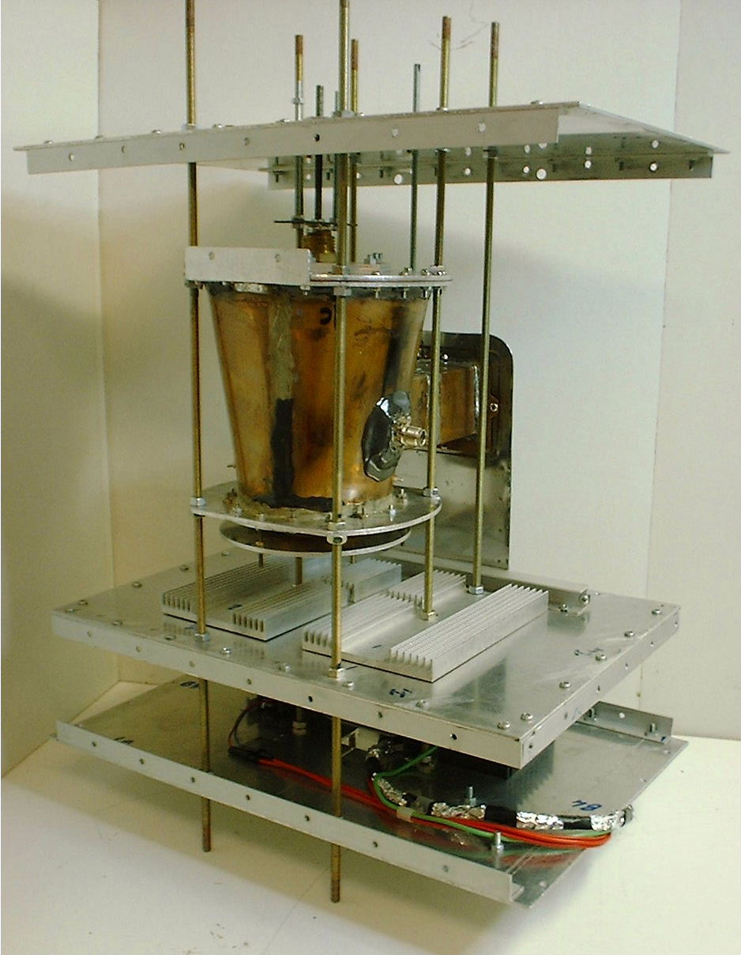
Fig 1. Diagram of engine concept
Fig 2. Experimental Thruster

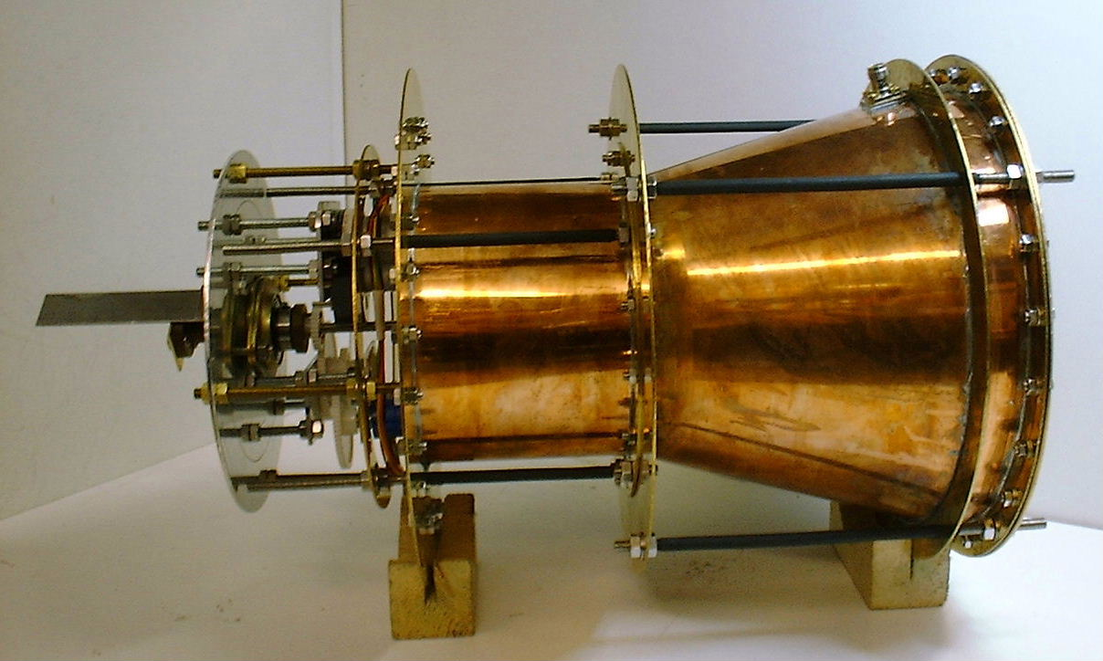
Fig 3. Thrust module of Demonstration Engine

Fig 4. Specific Thrust at 3 km/s.

