CEAS 2009

Session 11 27 October 2009 Manchester UK

THE EMDRIVE PROGRAMME – IMPLICATIONS FOR THE FUTURE OF THE AEROSPACE INDUSTRY

Roger Shawyer C.Eng. MIET. FRAeS
SPR Ltd, United Kingdom
sprltd@emdrive.com

1. INTRODUCTION

The theoretical basis of the EmDrive electric propulsion technology is now gaining worldwide acceptance. It is therefore timely to think ahead to the implications of this very disruptive technology on the future of the aerospace industry.

EmDrive technology provides direct conversion of electrical energy to thrust, using radiation pressure at microwave frequencies in a tapered, high Q, resonant cavity. For the first time, propulsion without the need for expelling reaction mass has been demonstrated. As the theory and experimental work clearly shows however, EmDrive is not a reactionless machine. It obeys Newtonian physics by producing an accelerating, reaction force opposite to the thrust vector. The law of conservation of energy is also obeyed, as is well illustrated by applying the dynamic thrust equation to a very high Q superconducting thruster.

The paper gives a summary of the theory behind EmDrive, followed by answers to the most frequently asked questions concerning the production of net force, conservation of momentum and conservation of energy. The theory clearly derives equations for both static and dynamic thrust.

An eight year R&D programme has been carried out with both UK government funding and private investment. Design software has been developed and verified during the manufacture and test of four different thrusters. The test programmes have consistently and repeatedly given thrust and acceleration measurements in close agreement with theoretical predictions. Great emphasis has been placed on eliminating or calibrating out any spurious force data during the tests, and technical reports have been independently reviewed by government and industry experts.

Two other groups, one in China and one in the USA are working on EmDrive projects. We understand that significant progress has been made in both theoretical and experimental work, within these groups. Reports have also been received of work in a further two countries. In the UK we have started the initial performance tests of our first flight thruster. It is anticipated that this thruster will be flown on a technology demonstrator mission.

Although EmDrive will clearly have a major impact on conventional in-orbit propulsion applications, the main object of this paper is to describe the results of a recent design study for a Hybrid Spaceplane. This vehicle utilises hydrogen cooled, superconducting EmDrive thrusters to provide the static lift. Acceleration is provided by hydrogen fuelled conventional jet and rocket engines. The results of a number of numerical analyses show remarkable performances for different missions. These include sub-orbital passenger transport, Earth orbit payload delivery, and a Lunar landing mission. This design study followed on from the first phase of an experimental, superconducting thruster programme.

2. PRINCIPLE OF OPERATION

The concept of the microwave engine is illustrated in fig 1. Microwave energy is fed from a magnetron, via a tuned feed to a closed, tapered waveguide, whose overall electrical length gives resonance at the operating frequency of the magnetron.

The group velocity of the electromagnetic wave at the end plate of the larger section is higher than the group velocity at the end plate of the smaller section. Thus the radiation pressure at the larger end plate is higher that that at the smaller end plate. The resulting force difference (F_{g1} -F_{g2}) is multiplied by the Q of the resonant assembly.

This force difference is supported by inspection of the classical Lorentz force equation

$F=q\left(E+\text{vB}\right)$ (1)

If v is replaced with the group velocity v_{g} of the electromagnetic wave, then equation 1 illustrates that if v_{g1} is greater than v_{g2}, then F_{g1} should be expected to be greater than F_{g2.}

However as the velocities at each end of the waveguide are significant fractions of the speed of light, a derivation of the force difference equation invokes the difference in velocities and therefore must take account of the special theory of relativity.

Relativity theory implies that the electromagnetic wave and the waveguide assembly form an open system. Thus the force difference results in a thrust which acts on the waveguide assembly.

3. DERIVATION OF BASIC THRUST EQUATION

Consider a beam of photons incident upon a flat plate perpendicular to the beam. Let the beam have a cross-sectional area A and suppose that it consists of n photons per unit volume. Each photon has energy hf and travels with velocity c, where h is Planck’s constant and f is the frequency. The power in the incident beam is then

(2)

The momentum of each photon is hf/c so that the rate of change of momentum of the beam at the plate (assuming total reflection) is 2nhfA. Equating this change of momentum to the force F₀ exerted on the plate, we find
(3)
(3)

which is the classical result for the radiation pressure obtained by Maxwell (reference 1). The derivation given here is based on Cullen (reference 2). If the velocity of the beam is v then the rate of change of momentum at the plate is 2nhfA(v/c), so that the force F_{g} on the plate is in this case given by

(4)

We now suppose that the beam enters a vacuum-filled waveguide. The waveguide tapers from free-space propagation, with wavelength λ_{0,} to dimensions that give a waveguide wavelength of λ_{g} and propagation velocity v_{g}. This is the group velocity and is given by
(5)

Then from (4) and (5) (with μ_{r} = e_{r} = 1) the force on the plate closing the end of the waveguide is

(6)

see Cullen (p.102 Eq. (15)).
Assume that the beam is propagated in a vacuum-filled tapered waveguide with reflecting plates at each end. Let the guide wavelength at the end of the largest cross-section be λ_{g1} and that at the smallest cross-section be λ_{g2}.
Then application of (6) to each plate yields the forces
,

Now λ_{g2} > λ_{g1}, due to the difference in cross-section, and hence F_{g1} > F_{g2}.
Therefore the resultant thrust T will be

(7)

4. FREQENTLY ASKED QUESTIONS
The considerable reaction caused by the New Scientist cover story in September 2006, identified three questions which caused most of the difficulties in understanding the concept.

(a) How can net thrust be produced ?
From (7) it can be seen that to maximise thrust, the taper design should ensure λ_{g1} approaches λ₀ consistent with an acceptable maximum dimension. Also λ_{g2} should approach infinity, which occurs when the minimum dimension approaches the propagation cut-off limit. This minimum dimension must be consistent with allowable manufacturing and thermal tolerances.
The resulting design must also ensure a low taper slope, to minimise the axial component of side wall forces. This combination of dimensional constraints requires an iterative numerical design approach, taking account of the highly non-linear relationship between radial dimensions and guide wavelengths. This relationship is illustrated in fig 2.
Fig 2 Guide wavelength for circular TMO1 at 2 GHz
It is clear that if the minimum dimension was the cut off diameter, force F_{g2} would be zero. However because there would still be a significant small end plate area, the projected area of the side wall would not equal the area of the large end plate. Thus any attempt to show a resultant zero net force due to equalisation of areas is incorrect.

Note also that if the forces had been the mechanical result of a working fluid within the closed waveguide assembly, then the resultant force would merely introduce a mechanical strain in the waveguide walls. This would be the result of a closed system of waveguide and working fluid.

In the present system, the working fluid is replaced by an electromagnetic wave propagating close to the speed of light and Newtonian mechanics must be replaced with the special theory of relativity. There are two effects to be considered in the application of the special theory of relativity to the waveguide. The first effect is that as the two forces F_{g1} and F_{g2} are dependent upon the velocities v_{g1} and v_{g2}, the thrust T should be calculated according to Einstein’s law of addition of velocities given by

The second effect is that as the beam velocities are not directly dependent on any velocity of the waveguide, the beam and waveguide form an open system. Thus the reactions at the end plates are not constrained within a closed system of waveguide and beam, but are reactions between waveguide and beam, each operating within its own reference frame, in an open system.

From (7) and (5) we find

where
.

Applying the above addition law of relativistic velocities we obtain

(8)

where the correction factor S_{o} is

We suppose that the waveguide is resonant at the frequency of the microwave beam and that the conductive and dielectric losses are such that there are Q return paths (each at power P₀). Then the total thrust is finally given by

$T=\frac{2P_{0}{\text{QS}}_{0}}{c}\left(\frac{λ_{0}}{λ_{g1}}−\frac{λ_{0}}{λ_{g2}}\right)$
(9)

(b) How is momentum conserved?

The concept of the beam and waveguide as an open system can be illustrated by increasing the velocity of the waveguide in the direction of the thrust, until a significant fraction of the speed of light is reached. Let v_{w} be the velocity of the waveguide. Then as each plate is moving with velocity v_{w} the forces on the plates, given by equation 6, are modified as follows:

$F_{g1}=\frac{2P_{0}}{c^{2}}\left(\frac{v_{g1}−v_{w}}{1−v_{g1}v_{w}/c^{2}}\right)=\frac{2P_{0}}{c^{2}}v_{\text{ga}}$
and
$F_{g2}=\frac{2P_{0}}{c^{2}}\left(\frac{v_{g2}+v_{w}}{1+v_{g2}v_{w}/c^{2}}\right)=\frac{2P_{0}}{c^{2}}v_{\text{gb}}$

The thrust is then given by

$T=\frac{2P_{0}}{c^{2}}\left(\frac{v_{\text{ga}}−v_{\text{gb}}}{1−v_{\text{ga}}v_{\text{gb}}/c^{2}}\right)$ (10)
The solution to (10) is illustrated in Fig 3. Note that to maintain the principle of the conservation of momentum, the acceleration of the waveguide due to thrust, is opposite to the actual thrust direction. Thus, in Fig 3, the sign convention for the waveguide velocity axis is:

Acceleration Vector Thrust Vector

Fig 3. Solution to equation 10

When the waveguide is accelerated along the acceleration vector, the thrust approaches a maximum of 1. However, as the velocity of the waveguide increases in the direction of thrust, the thrust will decrease to zero. This point is reached when v_{ga} = v_{gb}. Fig 3 illustrates the solution to equation 10 for values of v_{g1} = 0.95 c and v_{g2} = 0.05c. It can be seen that if v_{w} is increased beyond the value of 0.7118c, the thrust reverses.

Equation 10 illustrates that the thruster is an open system, where guide velocities are independent of waveguide velocity, and it is the relative velocities that give rise to the forces. Note that if Einstein’s law for the addition of velocities had not been used, relative velocities would exceed c, and the thrust would go above the theoretical limit of 1.

(c) How is energy conserved?

We now examine the implications of the principle of the conservation of energy when the thrust is first measured on a static test rig, and then when an engine is used to accelerate a spacecraft.

With the microwave engine mounted on a static test rig, all the input power P₀ is converted to electrical loss. In this case the Q of the engine may be termed Q_{u}, the unloaded Q.
Now $Q_{u}=\frac{P_{c}}{P_{0}}=\frac{P_{c}}{P_{e}}$
where P_{c} is the circulating power within the resonant waveguide and P_{e} is the electrical loss. From (9) we find

$T=\frac{2P_{0}D_{f}Q_{u}}{c}$,
Where D_{f} is the design factor
$D_{f}=S_{0}\left(\frac{λ_{0}}{λ_{g1}}−\frac{λ_{0}}{λ_{g2}}\right)$

Then $T=\frac{2D_{f}P_{c}}{c}$. (11)

Thus if the circulating power remains constant, for instance in a superconducting resonant waveguide, then T will remain constant. This will be important in non spacecraft applications where very high values of Q_{u} could be employed to provide a constant thrust to counter gravitational force.

If the engine is mounted in a spacecraft of total mass M and is allowed to accelerate from an initial velocity v_{i} to a final velocity v_{f} in time Δt, then by equating kinetic energies we obtain:
$P_{k}Δt=\frac{M}{2}\left(v_{f^{2}}−v_{i^{2}}\right)$

where P_{k} is the output power transferred to the spacecraft. From this we obtain
$P_{k}Δt=\frac{M}{2}\left(v_{f}−v_{i}\right)\left(v_{f}+v_{i}\right)$,

so that $P_{k}=M\overline{v}a$ (12)
where $\overline{v}$ is the average velocity over time Δt and a is the acceleration of the spacecraft.
Now M.a is the force due to the acceleration of the spacecraft, which opposes the thrust of the engine. Then

$P_{k}=\frac{2P_{0}Q_{l}D_{f}\overline{v}}{c}$

(13) (14)

where Q_{l} is the loaded Q of the engine when it is delivering an output power P_{k}.

The electrical power losses P_{e} are assumed to be I²R losses and thus for any value of Q ,
$P_{e}=Q^{2}P_{e0}$

where P_{e0} is the loss for Q=1. From the static case, we have
$P_{e0}=\frac{P_{0}}{Q_{u^{2}}}$

so that $P_{e}=P_{0}{\left(\frac{Q_{l}}{Q_{u}}\right)}^{2}$ (14)

For an accelerating spacecraft,

$P_{0}=P_{e}+P_{k}$

Substitution of (13) and (14) into this last equation then yields

${\left(\frac{Q_{l}}{Q_{u}}\right)}^{2}+\frac{2Q_{l}D_{f}\overline{v}}{c}=1$
(15)

Fig 4 Solution to equation 15.

Fig 4 shows the solution to (15) for values of $\overline{v}$ up to 10km/sec and for values of Q_{u} equal to 5x10³, 5x10⁴ and 5x10⁵. The value of D_{f} is taken to be 0.945.

For D_{f} equal to 0.945 and an average velocity of 3 km/s, the specific thrust is obtained from (9) and (15) and is given in fig 5. This illustrates that the specific thrust increases to a maximum of 333 mN/kW at this velocity.

Fig 5 Specific thrust at 3km/s.

(d) Is EmDrive similar to anything else?

EmDrive is a new class of electrical machine operating at microwave frequencies, and therefore bears little similarity to any other device. However, analogies are sometimes helpful in obtaining a mental picture of operating principles and the following mechanical analogy is offered for consideration.
EmDrive can be considered as an “electromagnetic flywheel”. As with a mechanical flywheel, a resonant cavity can store energy in the form of momentum. Due to the asymmetric geometry of the EmDrive cavity, the stored momentum can produce a linear force, which if used to accelerate a mass, transfers some of the momentum from the cavity. This transfer results in a loss of Q, and hence a reduction in the force available. However unlike a mechanical flywheel, the cavity is able to store and replace momentum very rapidly. The time constant of, a simple cavity operating at 4 GHz with a Q of 50,000 is 2 microseconds. Thus if acceleration is restricted, as with a large spacecraft being propelled with low thrust, continuous momentum transfer can take place, whilst maintaining the high Q.

5. EXPERIMENTAL PROGRAMME

The first experimental thruster was a 160 mm diameter device, operating at 2.45 GHz. The design factor, calculated from as-built measurements of the thruster geometry was 0.497. In 2001 a test programme was started and an unloaded Q of 5,900 was measured. The maximum thrust, measured using a precision balance was 16mN for an input power of 850W, which is very close to the thrust of 16.6mN predicted from equation (9).

The thrust could be varied from zero to maximum by varying the input power, or by varying the resonant frequency of the thruster. Considerable efforts were made to test for possible thermal and electromagnetic spurious effects. The primary method was to carry out all tests in both nominal and inverted orientations, and to take the mean of the results. The thruster was also sealed into a hermetic enclosure to eliminate buoyancy effects of the cooling air. Three different types of test rig were used, two using 1 mg resolution balances in a counterbalance test rig and one using a 100 mg resolution balance in a direct measurement of thruster weight.

Comparison of the rates of increase of thrust for the different spring constants, using pulsed input power, gave a clear proof that the thrust was produced by momentum transfer and was not due to any “undefined” spurious effect. The total test programme encompassed 450 test runs of periods up to 50 seconds, using 5 different magnetrons.

In 2003 a Demonstrator Engine development programme was started. Unlike the first experimental thruster, the Demonstrator Engine was rated for continuous operation and extensive design work was required to increase the specific thrust by raising the design factor and unloaded Q.

The engine was built to operate at 2.45 GHz, with a design factor of 0.844 and has a measured maximum Q of 45,000 for an overall diameter of 280 mm. The microwave source is a water cooled magnetron with a variable output power up to a maximum of 1.2 kW.

To obtain the predicted thrust, the engine was required to maintain stable resonance at this high Q value. Major design challenges included thermal compensation, tuning control and source matching.

The engine was tested in a large static test rig employing a calibrated composite balance to measure thrust in both vertical and horizontal directions. A total of 134 test runs were carried out over the full performance envelope.
Fig 7. Demonstrator Engine Static Test Data

Fig 7 gives test results for 3 Vertical Thrust test runs under the same input and tuner conditions but for thrust vectors in the Up, Down and Horizontal directions. This clearly illustrates the loss of measured weight for the Up vector, the increase in measured weight for
the Down vector, and a mean weight change close to zero, for the horizontal vector. These early, low Q, comparative tests yielded specific thrusts around 80mN/kW.

Fig 8 shows the results for a later, higher Q, test run, with the engine on the balance and then with it suspended above the balance. This illustrates the thrust measurements were not subject to EMC effects. Specific thrust for this test was 214mN/kW.

Fig 8. Electromagnetic Compatibility (EMC)

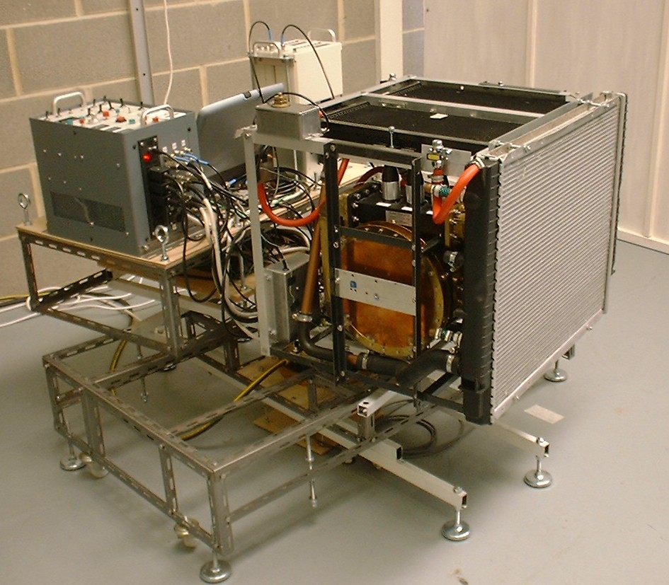

Fig 9. Demonstrator Engine on Dynamic Test

The engine was then mounted on a dynamic test rig enabling it to be “flown” on a rotary air bearing, as shown in fig 9.
The tests simulated the engine moving a 100Kg spacecraft in weightless conditions.

The test programme included acceleration and deceleration runs in both directions, and confirmed the thrust levels measured in the static tests.

Fig 10. Dynamic test results

Fig 10 gives the result of a typical test run, where the Demonstrator Engine produced a thrust of 10.4 gm against a calibrated friction torque of 7.1 gm. Input power was 421W, giving a specific thrust of 243 mN/kW.

The frequency offset curve shows that initial magnetron thermal drift ends with frequency lock. At this point, 130 secs into the test run, the velocity data shows the start of acceleration under power. The prior thermal drift period, with no acceleration, shows that the thrust is not a result of spurious thermal effects. When the power is turned off, at 210 secs, there is a coast period as the slosh effects of 5kg of coolant maintain a reduced acceleration. This is followed by the deceleration due to the friction torque. A maximum velocity of 2cm/s was achieved and a total distance of 185cm was “flown”.

The direction of acceleration was opposite to the direction of thrust, thus conclusively proving that the engine obeys Newton’s laws, and that although no reaction mass is ejected, the engine is not a reactionless machine. An electrical reaction occurs between the EM wave and the reflector surfaces of the resonator, resulting in an input impedance change with acceleration. This is seen in the power curve in fig 10.

6.FLIGHT THRUSTER PROGRAMME

The Flight thruster programme covers the design and development of a 300 Watt C Band flight thruster. This has a specified thrust of 85 mN, and a mass of 2.92Kg. Overall dimensions are 265mm diameter at the baseplate and a height of 164mm.

The thruster is designed to be powered from existing flight qualified TWTAs, which are driven from a dual redundant frequency generator unit (FGU) The FGU includes a frequency control loop using feedback signals from the thruster, as shown in the functional block diagram of the complete Flight Engine Fig 11.

isolators

TWTAs
FGU
Thruster
Fig 11. Flight Engine Block Diagram

Using the flight model design as the starting point, two lines of development will be followed.

Thrust Vector control.
A single plane, 360 degree, pointing mechanism will be developed and qualified to enable a set of 4 FM thrusters, each mounted on a mechanism, one on each spacecraft side panel, to carry out full 3 axis AOCS functions with the required redundancy. As there are no plume restrictions, the mechanism can be mounted inside the spacecraft, thus easing the environment specification. With each thruster orientated along the same axis, primary propulsion for orbit changing of medium sized satellites is available.

High Power operation.
By mounting the thruster externally on the spacecraft, on the lower panel where the ABM is normally mounted, a set of high power thrusters can provide the primary propulsion for LEO to GEO transfer of large satellites. A high power rating of 3.5kW per thruster can be achieved by updating the design, together with the addition of radiating fins. This would produce a target static thrust of 1N per thruster.

7.SUPERCONDUCTING DEMONSTRATOR PROGRAMME

The first phase of this programme was an experimental superconducting thruster. This low power, HTS device operates at liquid nitrogen temperature, and is designed for very high Q and consequently high specific thrust.
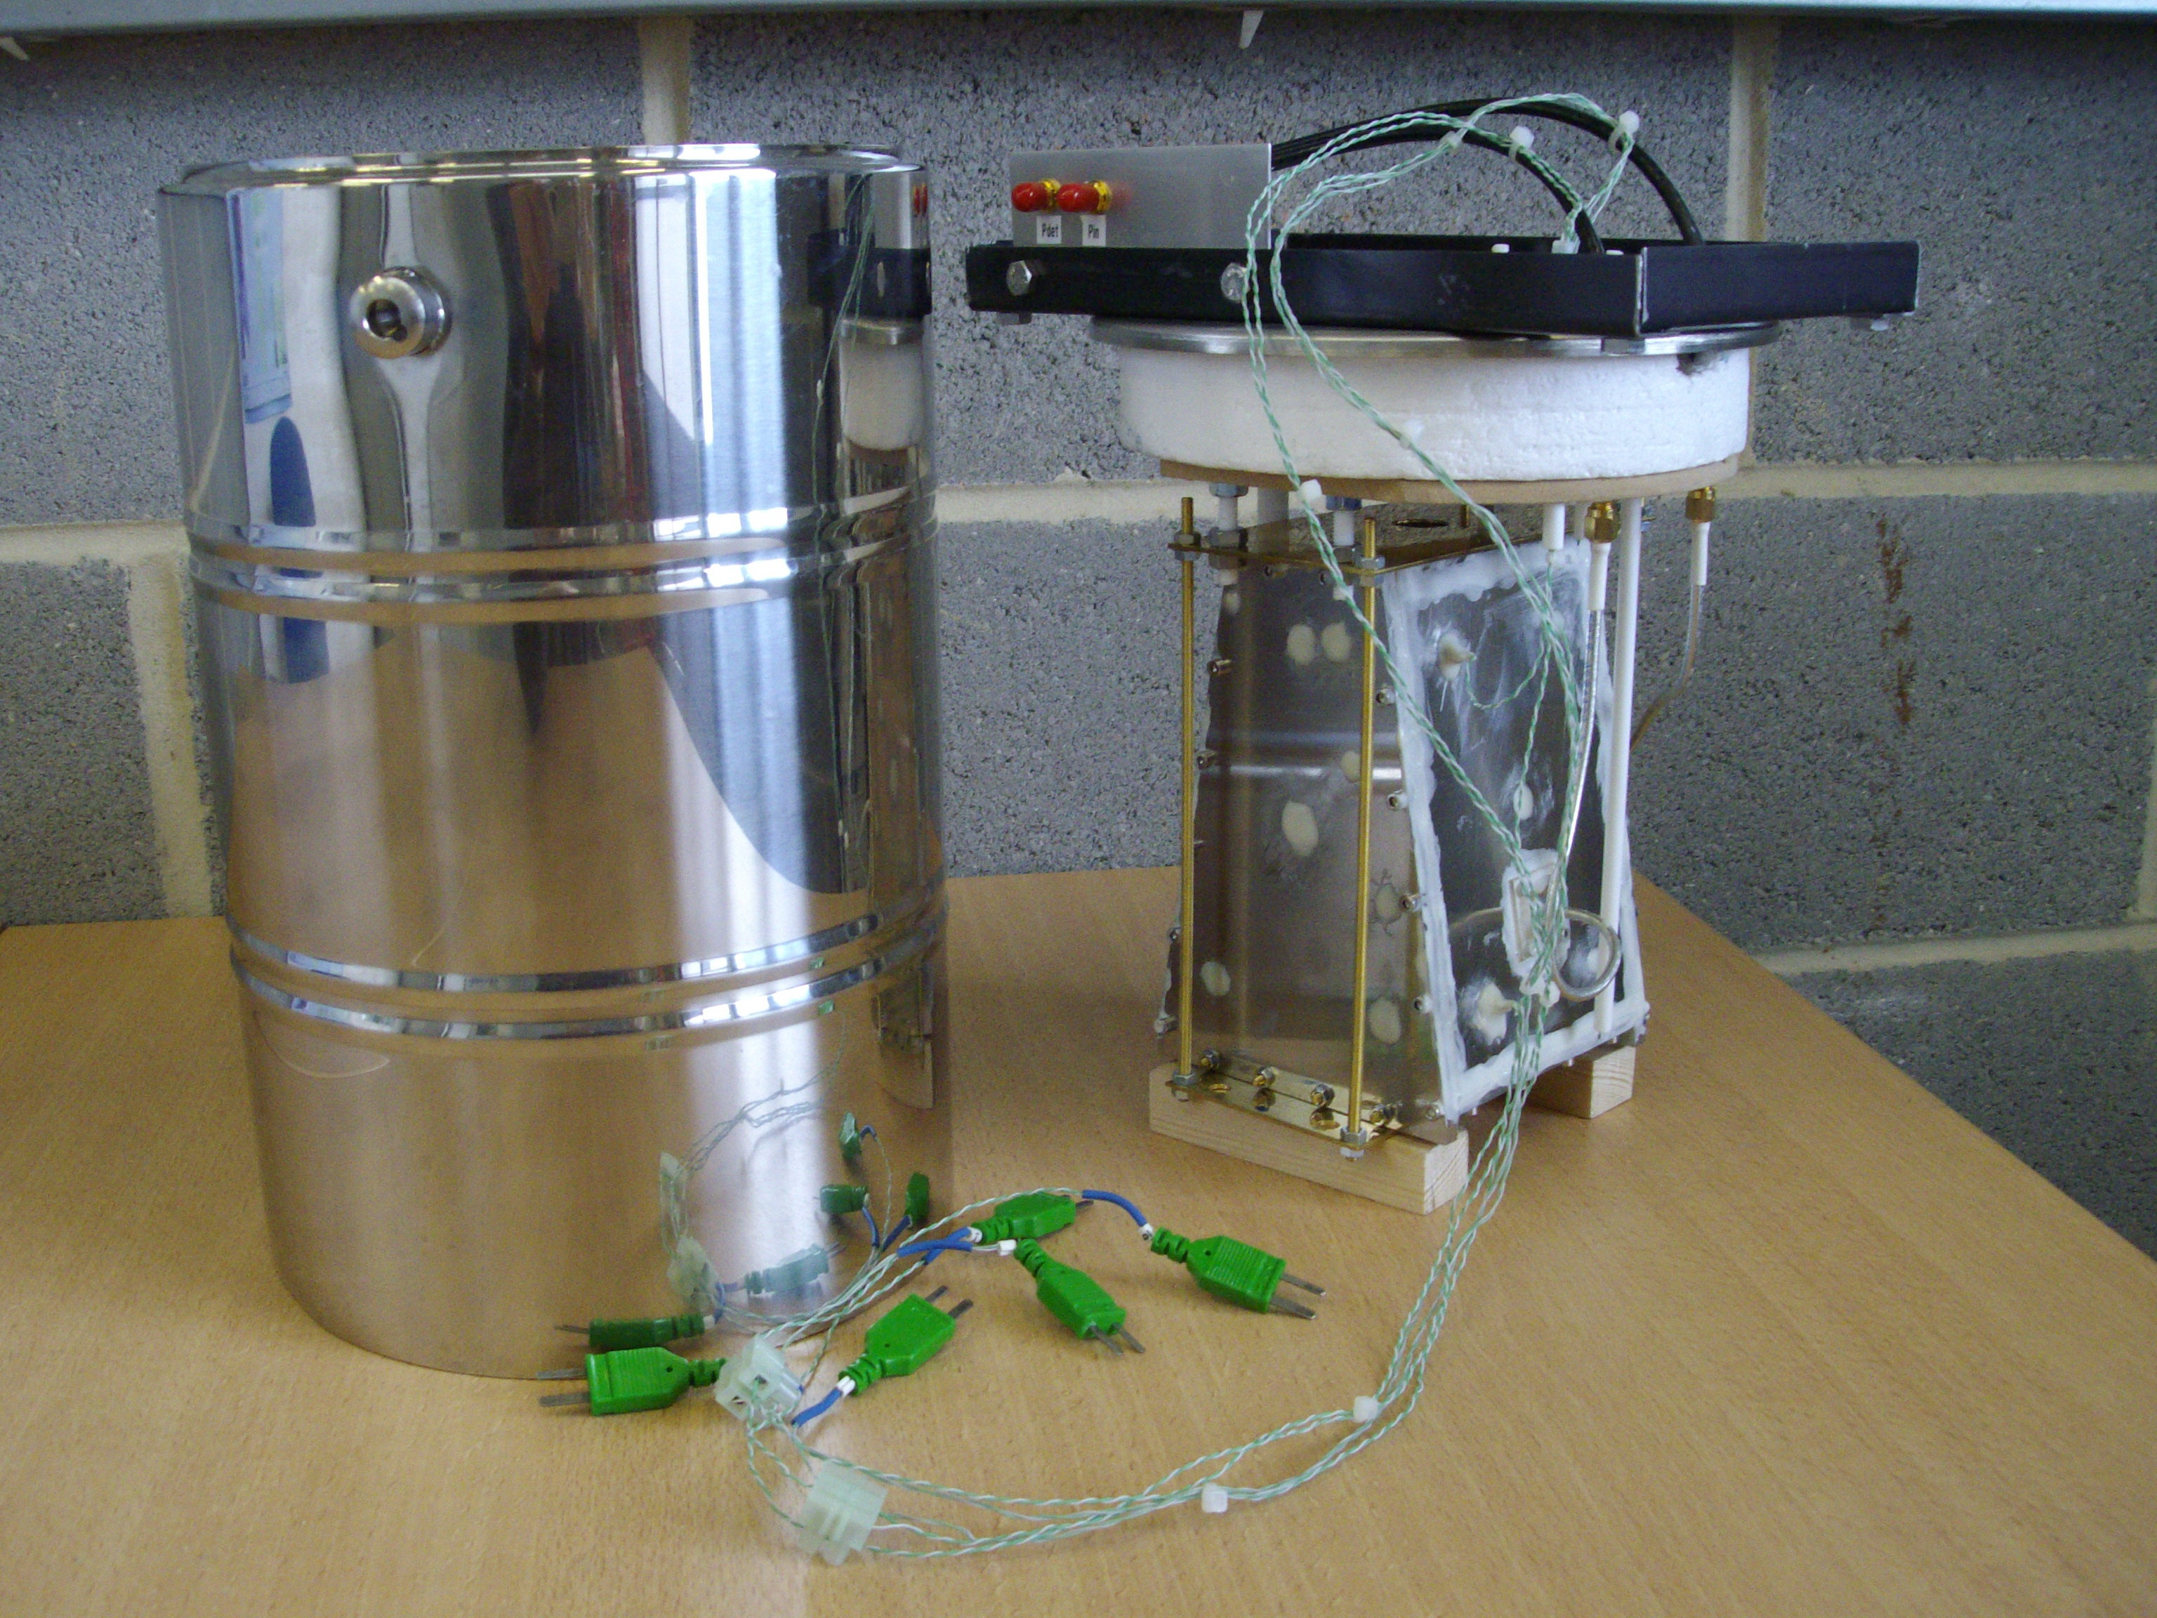
Fig 12 Experimental Superconducting Thruster

Fig 12 shows the thruster, which operates at 3.8 GHz, and was designed using an update of the software used for the previous S band designs. Super-conducting surfaces are formed from YBCO thin films on sapphire substrates.

Small signal testing at 77 deg K confirmed the design, with a Q of 6.8x10⁶ being measured.

Fig 13 shows the surface resistivity of the superconducting thruster based on specified manufacturer’s data, updated for the measured data.
Fig 13 Surface Resistivity

For the Demonstrator Thruster, cooling will be by liquid hydrogen. The design resistivity at 20deg K is therefore taken as 11.8 x 10⁻⁶ Ohms. This value was then used in the same design software used for the experimental 2G thruster. The resulting thrust was calculated as 143kg for 6kW input.

A design study was then undertaken on a simple 500kg unmanned Demonstrator Vehicle, illustrated in Fig 14. The basic vehicle consists of a 700 litre horizontal liquid hydrogen tank, supported by four lift engines.

A lift engine is based on the Demonstrator Thruster in a 5 litre dewar, mounted on a 2 axis +/- 30 degree gimbal mechanism. Two 3kW Travelling Wave Tubes (TWT) are positioned below the thruster. Mounted below the TWTs are two Electric Power Conditioners (EPC) providing the high voltages to the TWTs.

The total mass of the lift engine is predicted as 25.2 kg. This was calculated using the measured mass of the experimental thruster, together with scaled masses of a flight TWT and EPC.
An attitude control unit using feedback signals from a laser gyroscope is used to maintain the thrust axis vertical over the full gimbal range. A frequency generator and control unit (FGCU) completes the Lift engine.

To provide acceleration, the waste hydrogen gas boiled off from cooling the lift engines is used to power a pair of small Jet engines. A hydrogen fuelled motor-generator set is used to provide D.C. power. The jet engines are gimballed in one plane to provide horizontal or vertical thrust. Aerodynamic performance is improved with the addition of two side body fairings.

The vehicle which is illustrated in fig 14 has overall dimensions of 3.73m long, 1.91m wide and 1.16m high.

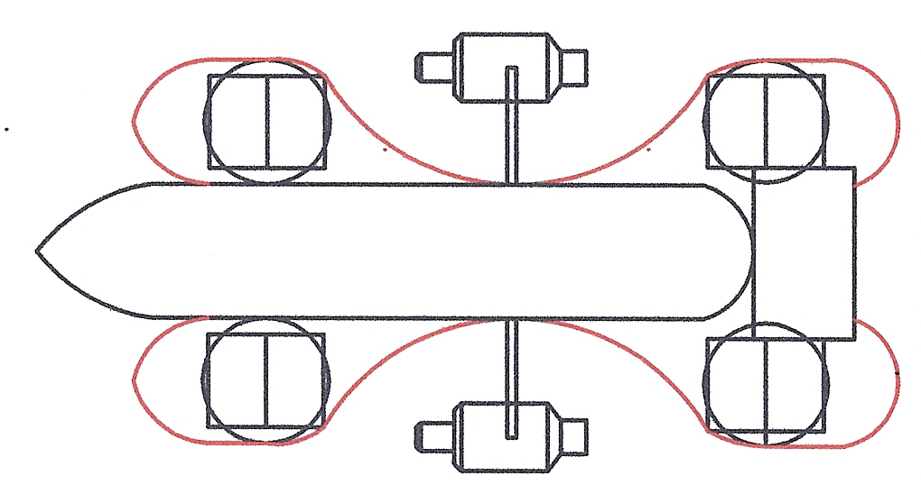

Fig 14 Demonstrator Vehicle

The design of the vehicle results from iterating a mass, power and thrust analysis with inputs from four mission analyses. The mass, dimensions and performance of the jet engines are scaled from the data available for the AMT Titan UAV engine. The power generator is based on an uprated ROTAX 503 aero engine driving a high speed 36 kW alternator.

From the dynamic thrust equation, (equation 15), it is clear that if the lift engine is used to accelerate the vehicle upwards, then at the high Q values obtained with superconducting thrusters, thrust will decrease rapidly. This is illustrated for the Demonstrator Vehicle in Fig 15.

Fig 15 Dynamic thrust

For 6kW of microwave input power at each thruster, the total lift thrust is 573kg. Thus for an estimated total vehicle mass of 477kg, the vehicle would start to accelerate upwards. However as the average velocity goes above 1m/s, the lift thrust approaches the vehicle mass, and acceleration stops. This is simply the principle of the conservation of energy at work, with energy used to accelerate the vehicle being lost from the stored energy in the thruster, hence lowering the Q.

Clearly, to achieve a useful rate of climb, the jet engines need to be rotated to give vertical thrust and the lift engine operation needs compensation to avoid losing stored energy. A method of compensation has been established theoretically, and one of the main objectives of the Demonstrator Vehicle programme will to be to show this compensation in operation.

The flight envelope was investigated by running 4 numerical mission analyses. These gave a maximum rate of vertical ascent of 52m/s (170ft/s) and a maximum speed of 118m/s (230 knots) at a maximum altitude of 12.6km (41,300ft). If the altitude is restricted to 1.34km (4,400 ft) then a full liquid hydrogen fuel load will give a maximum range of 97km (60 miles).

It is estimated that this very simple vehicle, using four, liquid hydrogen cooled, versions of the experimental thruster, could begin flight trials in 3 years time.

8. HYBRID SPACEPLANE

Following completion of the Demonstrator Vehicle study, a design exercise was carried out to investigate the potential for applying superconducting thrusters to a large multi-purpose spaceplane.

The basic Hybrid Spaceplane (HSP) concept is a VTOL carrier vehicle using eight EmDrive lift engines, two hydrogen fuelled jet engines with vertical lift deflectors and up to six hydrogen/ oxygen fuelled rocket engines. Electrical power would be provided by two fuel cells run on the boiled-off hydrogen gas from the lift engines, and liquid oxygen. The HSP is designed to carry a variety of payloads, and analyses have been carried out for the following missions:

- Long distance passenger transport using sub orbital flight.
- LEO payload delivery using additional orbital engines and fuel tanks.
- GEO payload delivery using additional orbital engines and fuel tanks.
- Lunar landing and payload delivery.

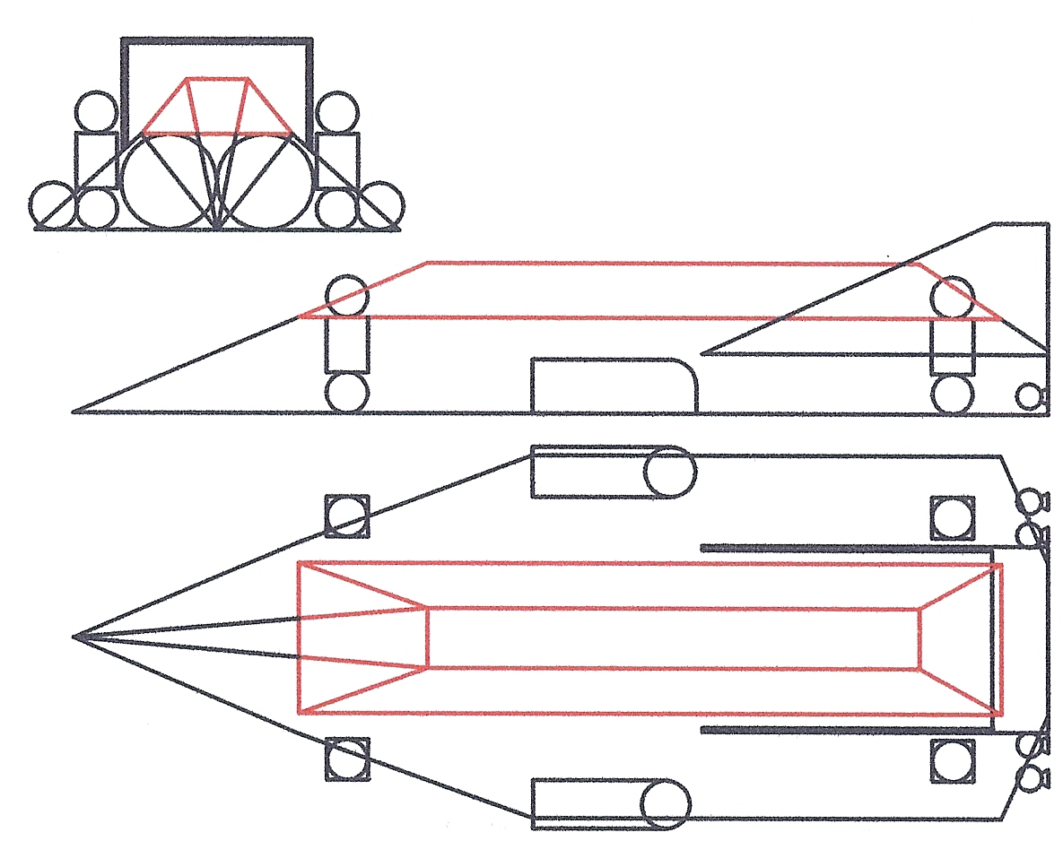

Fig 16 Hybrid Spaceplane. Sub-orbital configuration
Fig 16. illustrates the HSP carrier with the sub-orbital payload outlined in red. The overall dimensions are 35.5m long, 13.3m wide and 7m high. Carrier dry mass is 61.1 Tonnes. Maximum fuel load, liquid hydrogen (LH2) and liquid oxygen (LOX) is 190.5 Tonnes.
Mission analyses have shown that the maximum payload mass that can be carried is for the GEO mission, where a total mass of 63 Tonnes can be delivered to orbit. This includes the mass of the orbital engine and fuel tanks.
This gives a maximum launch mass of 314.6 Tonnes and an EmDrive lift requirement of 78.7 Tonnes per lift engine. The rocket engines are mounted in pairs and can be any combination of either ascent engines, with a thrust of 2 tonnes each or orbit engines, with a thrust of 20 tonnes each. Note that full 2 for 1 redundancy is envisaged for all carrier propulsion systems, as manned qualification status will be required, at least for the sub-orbital mission.

The airframe design for the HSP is based on a simple space frame with lightweight panels (mainly flat). There is no requirement for high mechanical or thermal stress in the HSP carrier vehicle. The mission analyses show the highest g level to be 0.58 g and maximum velocity in air to be 180 km/hr. However the design is aerodynamic (drag coefficient is estimated at 0.35) and the vehicle is capable of a glide landing in an emergency. Control surfaces for this situation are provided by the twin fin and tailplane configuration. A 2m scale model of the space plane has been built for aerodynamic investigations and is illustrated in fig 17.

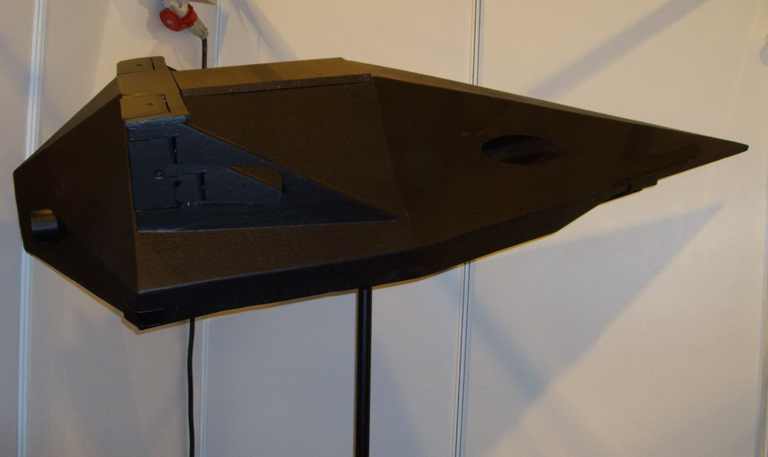

Fig 17. 2m scale model of spaceplane

Each mission was subject to a numerical analysis to calculate acceleration, velocity, height and distance from the thrust, drag and mass data for time increments through each phase of the mission. The results of the analyses were then used to iteratively optimise the spaceplane design.

The results of the mission analyses are given in table 1.

 | Missions
 | Sub  orbital | LEO | GEO | Lunar
Distance  (km) | 16,890 | 250 | 36,000 | 382,538
Mission time (hours) | 2.63 | 1.98 | 59.83 | 105.58
Max velocity  (km/s) | 4.14 | 7.79 | 3.07 | 2.17
Max Carrier g | 0.32 |  |  | 0.58
Max Payload g |  | 4 | 1.5
Payload Mass (Tonnes) | 58.7 | 15.9 | 49.4 | 44.1

Table 1. Mission Analysis Results

The London to Sydney sub-orbital mission starts with a vertical take-off with the spaceplane in a horizontal attitude. Lift is provided by the EmDrive thrusters and vertical acceleration by the jet engines. At 12km altitude the ascent rocket engines are fired to maintain the climb to a cruise altitude of 96km At this height, the orbit engines are fired to accelerate the spaceplane to a cruise velocity of 4km/s. At 90 minutes into the flight, deceleration starts, using the lift engines in a braking mode. Note that when used for deceleration, the EmDrive lift engines are not subject to the dynamic thrust limitation, as no energy is being lost from the stored energy in the resonant cavity. Descent and a vertical landing are controlled by both the lift engines and the jet engines.

The two Earth orbit missions use the carrier vehicle to achieve an altitude above the required orbit height. The takeoff and landing phases are similar to the sub-orbital mission, with the ascent phase extended until the required altitude is reached. The payload vehicle, comprising payload, rocket engines, and fuel tanks, is then dropped from the carrier vehicle and the engines are ignited. For the LEO mission, two 100 tonne thrust engines are required, whilst for the GEO mission only one is used. For these missions the spaceplane carrier vehicle can be viewed as a “space elevator without cables”.

The Lunar landing analysis illustrates the dramatic improvements possible for future missions. The Earth orbit cruise phase is extended to a distance where the vehicle comes within the gravitational influence of the moon. The lift engines are then used to control descent to the Lunar surface. A precise landing position can be achieved by using the gimballed ascent engines for horizontal and vertical movement, whilst the lift engines provide hover. Lunar take-off uses the 20 tonne thrust engines to achieve return velocity, with the lift engines used to control deceleration and descent into the Earths atmosphere. The landing phase is similar to the previous missions.

9. CONCLUSIONS

The theory and principles of operation of EmDrive have been given, together with the derivation of the equations used to predict performance. The development of the theory and its verification have been supported by a lengthy experimental and demonstrator programme in the UK. Some results from this programme have been given. This theoretical and experimental work has been independently verified by groups working outside Europe. It is therefore confidently predicted that within a few years, the use of first generation EmDrive technology will provide significant improvements in mission performance, for all space applications. It is important that Europe does not lose out in this field.

However the major impact of this technology will occur in the aircraft industry when second generation superconducting EmDrive thrusters are used as a lift engines in hybrid air and space vehicles. Once the requirement for aerodynamic lift, or ballistic trajectory, is removed from air transport or space vehicles, mission analysis has to be re-thought. The design studies for an early Demonstrator Vehicle and a future Spaceplane have shown that small VTOL vehicles, using simple low stressed airframe design, could capture the personal transport market. The combination of the commercial microwave industry and a future automobile industry, with liquid hydrogen storage and fuel cell capability, would render the existing short and medium haul aircraft industry redundant.

The future of the aircraft industry would then rely on the high speed long distance sub- orbital spaceplane. However this requires no improvement in existing airframe design, other than an ability to operate in vacuum. No high velocity in the atmosphere is required, and the vehicle is not subject to high g forces or extreme thermal environments. London to Sydney in under 3 hours, using hydrogen fuel could be a reality in under 10 years, although it may not be a European vehicle that demonstrates this. VTOL is of course part of the attraction of all EmDrive based applications.

Finally, the need to refocus the aircraft industry in the face of these technology changes, will also lead to space applications becoming important. Solar Power Satellites form a large future market, which clearly requires low cost access to GEO. The Hybrid Spaceplane will finally make this industry financially viable, and at the same time provide an answer to the global need for a green energy source.

ACKNOWLEDGEMENTS

The author is grateful for the assistance given by colleagues in SPR Ltd, by Dr R B Paris of Abertay University, Dundee, by J W Spiller of Astrium UK Ltd and by Professor J Lucas of The University of Liverpool. The early theoretical work and experimental programmes were carried out with support from the Department of Trade and Industry under their SMART award scheme, and then under a Research and Development grant. Recent programmes have been funded by substantial shareholder investment.

REFERENCES

1. MAXWELL J.C. ‘A Treatise on Electricity and Magnetism’
1st Edition (Oxford University Press 1873) p.391.

2. CULLEN A.L. ‘Absolute Power Measurements at Microwave Frequencies’ IEE Proceedings Vol 99 Part IV 1952 P.100

